«Спорт в нашей жизни» / “Sport in our life” | февраль 16  2022
Разработка открытого урока английского языка в 11-А классе |  | Учитель английского языка Темирбек кызы Саламат

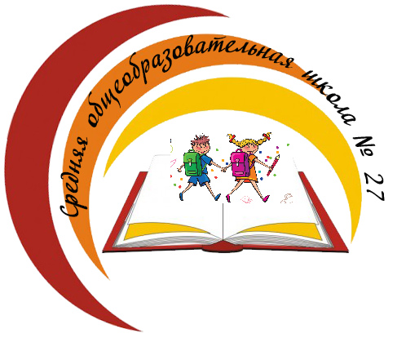
Бишкек шаары
Биринчи май району
№ 27 жалпы билим
берүүчү орто мектеби

План – конспект урока английского языка
Тема: «Спорт в нашей жизни» / “Sport in our life”
Цель урока: развивать коммуникативную компетентность учащихся
Цели:
Образовательная: Совершенствовать лексико-грамматические навыки говорения по теме «Спорт в разных видах речевой деятельности: аудирование, говорение, чтение, письмо. Совершенствование грамматических навыков: употребление play, do, go с видами спорта;
Развивающая: Развивать речевые и познавательные способности, память, мышление, мотивацию к изучению иностранного языка как новому средству общения; развитие фонетических навыков и навыков чтения с полным пониманием прочитанного;
воспитательная: Поддерживать интерес к английскому языку, воспитывать потребность здорового образа жизни, развивать умение работать индивидуально и в группе

Оснащение урока: презентация, раздаточный материал, видеоматериал

Ход урока:
1.Приветствие.
T (teacher): Good morning students. I’m very glad to see you.
Р:: Good morning
T: Sit down, please. Let’s start our lesson. What date is it today? Write to your copy-books.Checking home work. Закрепление тему

2.Фонетическая зарядка

T: At first let’s practice the English pronounciation.
The thirty three thieves thought that they
Thrilled the throne throughout Thursday

New theme:Look at the screen everyone!How do you think what about will we speak today?What is this lesson about?

3. Речевая разминка. ( говорение/ вопросы задает учитель)
Answer my questions:
- Do you like sport?
- Do you like to watch it on TV or do it by yourself?
- What kind of sports do you know?
- What is your favourite summer sport?
- What is your favourite winter sport?
- What kinds of sport are popular in Russia?
- What national English sports do you know?
Football
Tennis (Wimledon)
Golf (golf-widow)
Cricket (that`s not cricket)
Rugby
(сообщение во время ответов, интересных фактов про английские виды спорта)
4. Listen to the riddles and guess what kind of sport it is. (на презентации слайд, я читаю, они следят и отвечают)
1. winter sports
2.games with ball
3.water sports
4.other kinds pf sports
5.national games
You are right.
5. Работа в группах.
- Many people like sport. But a great number of people don’t go in for sports. Are you good or against sport? Let’s divide in groups of four people to think good and bad sides of sport. (делятся на группы по 5человека, обсуждают плюсы и минусы спорта)
Ok, work in groups. You have three-four minutes.
Ответы студентов:
Sport is good because
It makes me strong and fast
It helps me to keep fit
It builds character
It teachers me to win and to lose
It’s very good for my heart
We enjoy it
Sport helps people to stay in good shape
helps to support health
prevents from illness.
Sport is bad because
It’s not very useful.
It takes a lot of energy and time.
We have no time to walk with friends
It needs to work very hard.
It can be risky
We can break legs and arms
Can be expensive, depending on sport.
- So there are a lot of good sides
And we can tell, that sport helps us to live a healthy life
So, to live a healthy life we must: (Итак, чтобы вести здоровый образ жизни нужно):
Go in for sport
To walk
Have a rest
Daily routine
Not smoke
Not drink alcohol
AND OF COURSE EAT HEALTHY FOOD
Посмотрите на слайд – это здоровое питание
На 2-м – нездоровое питание

6. Использование глаголов PLAY, DO, GO с видами спорта
Play is used with ball sports or competitive games
Do is used with activities that can be done alone
Go is used with activities that end –ing

What sport we can… PLAY ? GO ? DO ?
PLAY | DO | GO
Aerobics handball jogging
Skating ice hockey karate
Football gymnastics tennis
swimming
Ответы: Play – Football, ice hockey, handball
Do – Aerobics, gymnastics, karate
Go – Skating, jogging, horse riding, swimming
7.Exercise Make up word combinations
8. Let`s read the text. The student from our college told me about sport. His name is Victor.
Sport is very important in our life. It is popular among young and old people.
Many people do morning exercises, jog in the morning and train themselves in clubs, in different sections and take part in sport competitions.
Children and grown-ups must take care of their health and do morning exercises regularly.
There are some popular kinds of sports in our country: football, volley ball, hockey, gymnastics, skiing, skating. Athletics is one of the most popular kinds of sports. It includes such kinds of sports as: running, jumping and others. Everybody may choose the sport he (or she) is interested in.
There are summer and winter sports.
As for me I like football. It needs mobility, liveliness and much energy. It keeps a person in a good form. I get a real joy taking part in competitions or simply playing with my friends. My favourite football team is BARSELONA and my favourite football player is Leo Messi.
Vocabulary:
Competition – соревнование
Jog – бег трусцой
It includes – включает в себя
mobility — мобильность
liveliness – бодрость, бодрое настроение

Say is it true or false:
- Sport is not important in our life.
- A lot of people do morning exercises.
- There are some popular kinds of sports in our country: rugby, cricket, baseball and others.
- Swimming is one of the most popular kinds of sports.
- Victor likes volleyball.
- His favourite football team is Manchester United.
- His favourite football player is Ronaldo.
9.Watch the video
You should watch this video and try to understand point of this video

10. Conclusion. ( д/з,оценивание)
Guys.you were very active today. Give marks to student. Home work:learn by heart tongue twister and read that text again

УПРАЖНЕНИЯ для активизации лексики
Упражнение. Find the words.
hoc | ping
swim | ling
foot | key
wrest | ball
aero | nis
jum | ball
volley | bics
ten | ming

