Открытый Урок на тему; “Our health and healthy lifestyle”
Учитель: Каримова Диляром Мирикрамовна
Предмет: Английский язык
Дата: 14.02.2018г. Класс: 10 (б+в)
Цель урока: - обобщить и систематизировать знания учащихся по разделу “ Our health and healthy lifestyle ”
Задачи урока: образовательная: - закрепление грамматики перевода из прямой речи в косвенную;
- развитие речевых умений (диалогическая и монологическая форма речи);
- активизация лексики по теме «Здоровье»;
развивающая: - развитие воображения , внимания, памяти;
- воспитательная: формирование ценностного отношения обучающихся к своему здоровью.
Оснащение урока: компьютер, проектор, аудиозапись, колонки, раздаточный материал

Ход урока.
Орг.Момент:
Good afternoon! How are you? Sit down, please. What is the date today? What Is the day today?
What can you say about the weather today? Do you like it?
Today we are going to speak about Health. I don’t think there is anything more important than health. Do you agree with this? Could you remember me, please, what Russian people say when they meet each other. Yes,they say «Здравствуйте!».Do you know what does it mean? Yes, It means that they wish each other to be healthy.
And here some proverbs about health:
Wealth is nothing without health. – Здоровье дороже денег. Не рад больной и золотой кровати.
Good health is above. – Здоровье всего дороже. Здоровье дороже всякого богатства.
A sound mind in a sound body. – В здоровом теле здоровый дух
An apple a day keeps the doctor away. – Лук семь недугов лечит, а чеснок семь недугов изводит.

What are they? How do you understand them? Фонетическая разминка.

[ɒ] – swallow, cough, product, dairy product
[θ] – throat, throw-threw-thrown, overthrow-overthrew-overthrown [ai] – diet, fry
[i] - bitter
Лексическая рaзминка.
To feel better after the illness (recover) The upper, front part of the body (chest) You can feel it if you touch it (pulse) Our organs of breathing (Lungs)
And now I am going to set you riddles and you are to guess them:
The front of the neck (throat)
To move food or drink down the throat to the stomach (swallow) If you want to be fit you should keep to a …. ( diet)
When you do it people wish you to be healthy (sneeze) Yoи ake it when you are ill (a medicine)
Ok, good job, guys! So, the theme of our lesson is a healthy lifestyle. I)Think and say what are the main rules of a healthy lifestyle.
Go in for sports, Eat healthy food, keep to a diet, keep daily routine, go to bed early and get up early….
And what shouldn’t do to keep fit?
Eat fast food, Smoke, drink alcohol, sit in front of the computer for a long time, sit too long…
- Let’s talk about your daily routine.
- How often do you do your morning exercises?
- Do you clean your teeth before meal or after it?
- How long does it take you to do your homework?
- When do you go to bed?
- Do you often sit late?
- Let’s talk about healthy food. 1.What healthy food do you know? 2.Do you often eat fast food? 3.Why is it bad to eat fast food? 4.Why is it bad to drink Coca-Cola?

5.How often should we visit a dentist?

Well, I’d like you to listen to a story about Tim, Before listening to the text answer the questions:
1.How often do you go the doctor? 2.Who helps you when you are ill? 3.What should you do to keep fit?

Listen to the text and do the task after it.(turn on the audio) Tim Takes Medicine
It is winter now and John is ill. He is coughing, he has a terrible headache and feels a pain in his chest. The doctor came yesterday. He felt the boy's pulse and listened to his lungs. He touched John's head and immediately gave him some medicine. The doctor told John to stay in bed and take the medicine regularly 3 times a day.
Now there is a bottle of medicine on John's table near his bed. But John doesn't want to take it. "What shall I do?" he thinks. "What shall I do not to take the medicine?"
Suddenly he remembers Mark Twain's Tom Sawyer and his cat. John read the book about them last summer. So John gets out of his bed,takes his big black cat Tim and gives him his medicine, Tim likes the medicine and begins to drink it. But at that moment John's mother comes into the room. She sees John, Tim and the bottle of medicine. She understands everything. "Don't be silly, John," she says. "You should drink the medicine, not the cat. You are ill, the cat isn't. But the cat may feel bad because of the medicine. You shouldn't give it to Tim. Be a good boy, take a spoon of the medicine and try to sleep."

Make the right choice: ‘True’, ‘False’ or ‘Don't Know’.
- It is winter now.
- Tim is ill
- John isn't coughing.
- The doctor told John to stay in bed,
- The doctor told John to go for a walk.
- John didn't want to take medicine.
- John has many pets at home.
- The boy gives the cat his medicine.
- Tim doesn't like the medicine.
- John's mother told him to take the medicine.

And now lets answer on some main questions:
- Did John like the medicine?
- What story did he remember? Mark Twain’s Tom Sawyer and his cat.
- What did John do?
- Did Tim like the medicine?
- Who came into the room?
- What did she say?

Ok, now we have to try to imagine that you are ill and you come to the doctor. Dialogue 1. Eleonora and Adilet
Dentist: Hello!
Patient: Hello!
Dentist: What’s the matter? Patient: I’ve got an awful toothache. I used a hot water bottle, I took different tablets, but nothing could help me. D.: Open your mouth, please. Show me your teeth. What tooth hurts you? Oh, your teeth are so bad. Do you brush your teeth? P.: Oh, yes, I do. D.: How often do you brush your teeth? P.: Sometimes often, sometimes seldom. D.: You must brush your teeth more than three times a day. And you must visit the dentist twice a year. But now I’ll extract your tooth. It’s too bad.
P.: Oh! My God!

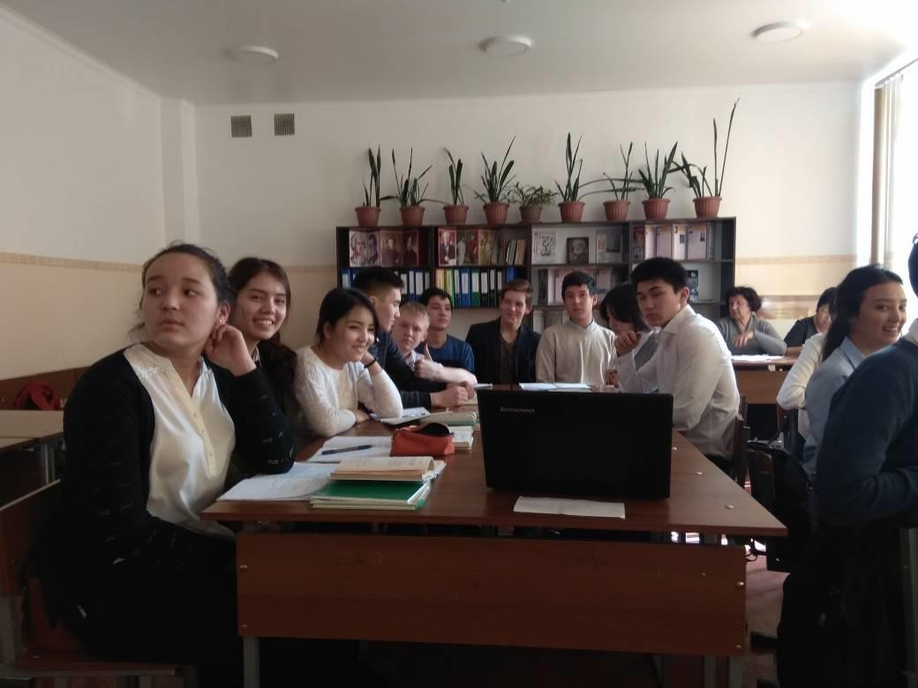

УЧАЩИЕСЯ ОЧЕНЬ ЗАИНТЕРЕСОВАНЫ УРОКОМ
Dialogue 2. Igor and Cholpon
Doctor: Would you like to come in? Patient: Thank you. (He coughs.) D.: That cough sounds really very bad. How long have you had it? P.: For about two weeks. D.: I think I should listen to the chest and lungs. Take off your shirt. Breathe in deeply, that’s right… and once more, please. Sit down. I’m going to take your blood pressure. P.: Oh, doctor, what about my lungs and chest and blood pressure? D.: You are seriously ill. Your blood pressure is 60/90. It is very bad. Do you smoke?
P.: Yes, about three cigarettes a day. D.: You should not smoke at all. Your health is in danger.
P. Oh, doctor, I’m afraid. What should I do? D.: First of all stop smoking, take regular exercise, eat healthy food and go

in for sport. P.: Thanks, doctor. I shall follow your advice.

Dialogue 3. Mirlan and Meerim
Doctor: Come in, please. Sit down. What troubles you? Patient: Oh, doctor. It is difficult for me to breathe, to move, to go upstairs. I am always hungry. D.: Let me take your blood pressure and listen to your heart. Breathe, breathe in deeply. P.: What about my heart and blood pressure? D.: Show me your tongue, please. You have a heart attack. You are seriously ill. You suffer from fatty heart. It is dangerous. P.: Oh, doctor. Can you help me? What can you advise me? D.: Keep to a diet. Eat more fruits and vegetables. Don’t forget the proverb “An apple a day keeps the doctors away”. P.: Thanks, doctor. I shall follow your recommendations.

Итоги: ok,my dear students, let’s revise our lesson again: What are the main rules if you want to keep fit?
Your marks are _

Thanks for cooperation and goodbay

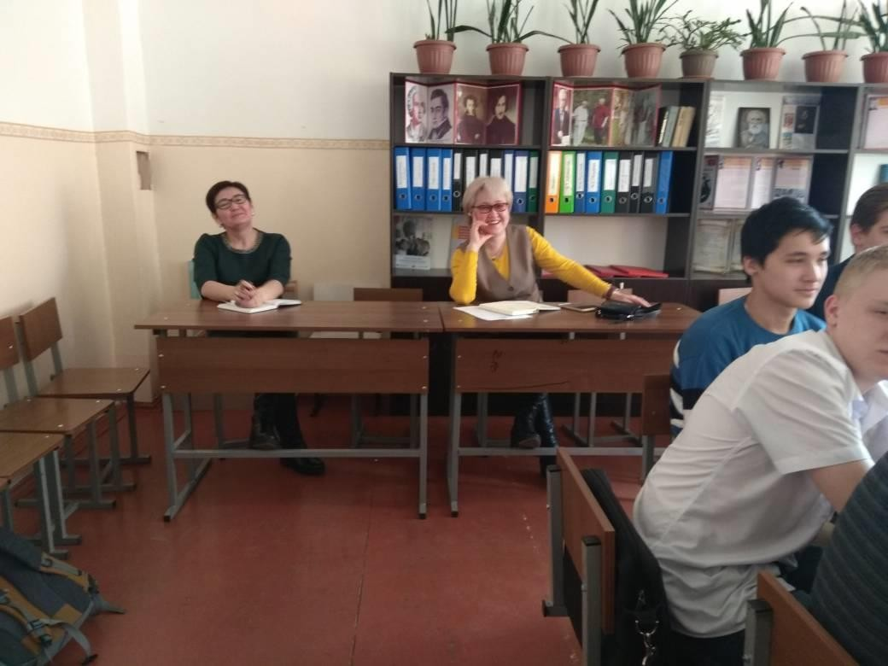

ПРИСУТСТВУЮЩИМ УЧИТЕЛЯ БЫЛО ИНТЕРЕСНО

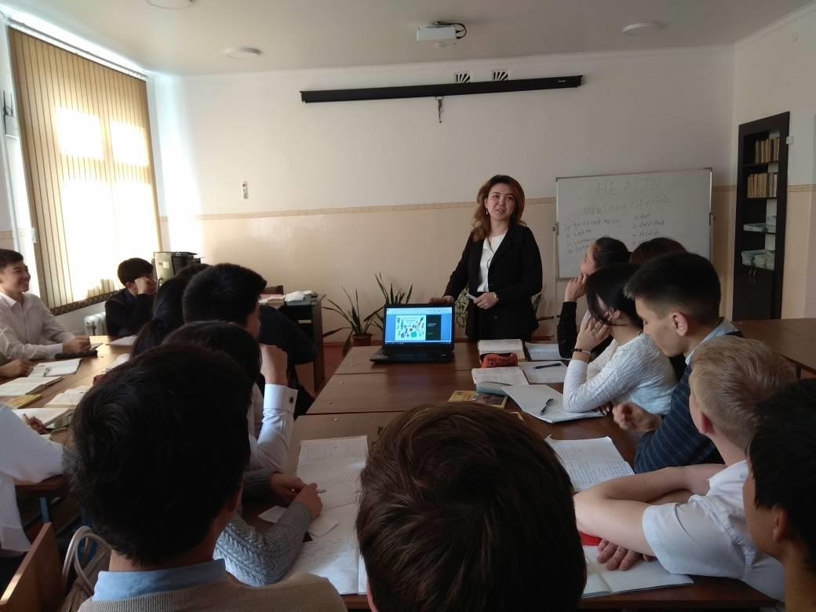

КРАСИВАЯ И ПОНЯТНАЯ РЕЧЬ УЧИТЕЛЯ

